Software Design Document (SDD)
Module: TIM (Hardware Timer) Driver
STM32F4xx — Microcontrollers and Embedded Systems, CETYS Universidad
Module | TIM (Hardware Timer) Driver
Version | 1.0
Authors | David Mijares, Aldo de la Torre, Jose Paez
Platform | STM32F4xx
Clock | 16 MHz (HSI)
Course | Microcontrollers and Embedded Systems — CETYS Universidad

1. Introduction

1.1. Purpose
This document describes the software design and architecture of the TIM (Timer) driver module for the STM32F4xx microcontroller family. Based on the requirements defined in the corresponding Software Requirements Specification (SRS), this SDD provides detailed information on data structures, algorithms, register-level operations, and control flow required to guide implementation, integration, and unit testing of the driver.

1.2. Scope
The TIM driver is a low-level software component for embedded real-time applications. It abstracts the STM32F4xx hardware timer peripheral registers and provides a clean, index-based API that higher-level application modules can use to:
- Generate blocking time delays (millisecond resolution).
- Produce periodic signals at a user-defined frequency.
- Configure output-compare channels for PWM or event generation.
- Enable and disable individual timer instances and compare channels.

1.3. Definitions and Acronyms
Term | Definition
TIM | Hardware Timer peripheral on STM32 microcontrollers
PSC | Prescaler register — divides the input clock before reaching the counter
ARR | Auto-Reload Register — defines the period (overflow value) of the counter
CCR | Capture/Compare Register — value against which the counter is compared
CCMR | Capture/Compare Mode Register — configures channel operating mode
CCER | Capture/Compare Enable Register — enables/disables channel outputs
UIF | Update Interrupt Flag — bit 0 of SR, set when counter overflows/underflows
CEN | Counter Enable — bit 0 of CR1, starts or stops counting
EGR | Event Generation Register — writing UG (bit 0) forces a register update
RCC | Reset and Clock Control — peripheral responsible for enabling bus clocks
APB1/2 | Advanced Peripheral Bus 1 / 2 — buses that supply clock to timer peripherals
CMSIS | Cortex Microcontroller Software Interface Standard — register header files
tim_t | Enumeration typedef representing a logical timer index (0–7)

1.4. Requirements Reference
All requirements specific to this module are allocated in:

docs/SRS/TIM_Driver_SRS_v1.0.docx

2. System Architecture

2.1. High-Level Design
The driver follows a strict three-layer architecture that separates application concerns from hardware details:
- Application Layer — User code that calls TIM driver public API functions (e.g., tim_setTimerMs(), tim_waitTimer()) without needing to know about register addresses.
- TIM Driver Layer — Implements all timer logic. Validates inputs, computes prescaler and auto-reload values, and writes directly to hardware registers through the CMSIS-provided TIM_TypeDef pointer array.
- Hardware Layer — The actual STM32F4xx TIM1, TIM2, TIM3, TIM4, TIM5, TIM9, TIM10, and TIM11 peripheral register banks, accessed via the global TIM[] pointer array initialised by tim_init().

2.2. Module Interfaces
- Public API — All externally callable functions are declared in TIM.h and defined in TIM.c.
- Dependencies — The driver depends on the CMSIS stm32f4xx.h header for TIM_TypeDef and RCC_TypeDef register definitions, and on stdint.h for fixed-width integer types.
- No inter-driver dependencies — The TIM driver does not call GPIO or any other peripheral driver directly.

3. Detailed Design

3.1. Class Diagram
The diagram below shows the static structure of the TIM module and its relationships with the CMSIS hardware abstractions.

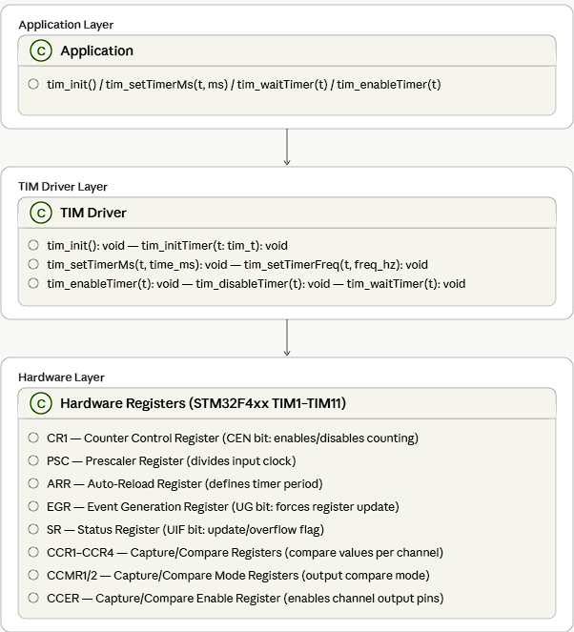
Figure 1. Class Diagram – TIM Driver

3.2. Module Behavior
The following diagrams capture the dynamic behavior of the most relevant driver operations. Sequence diagrams show the interaction between actors and objects over time; activity diagrams show the internal control flow of individual functions.

3.2.1. Timer Initialization
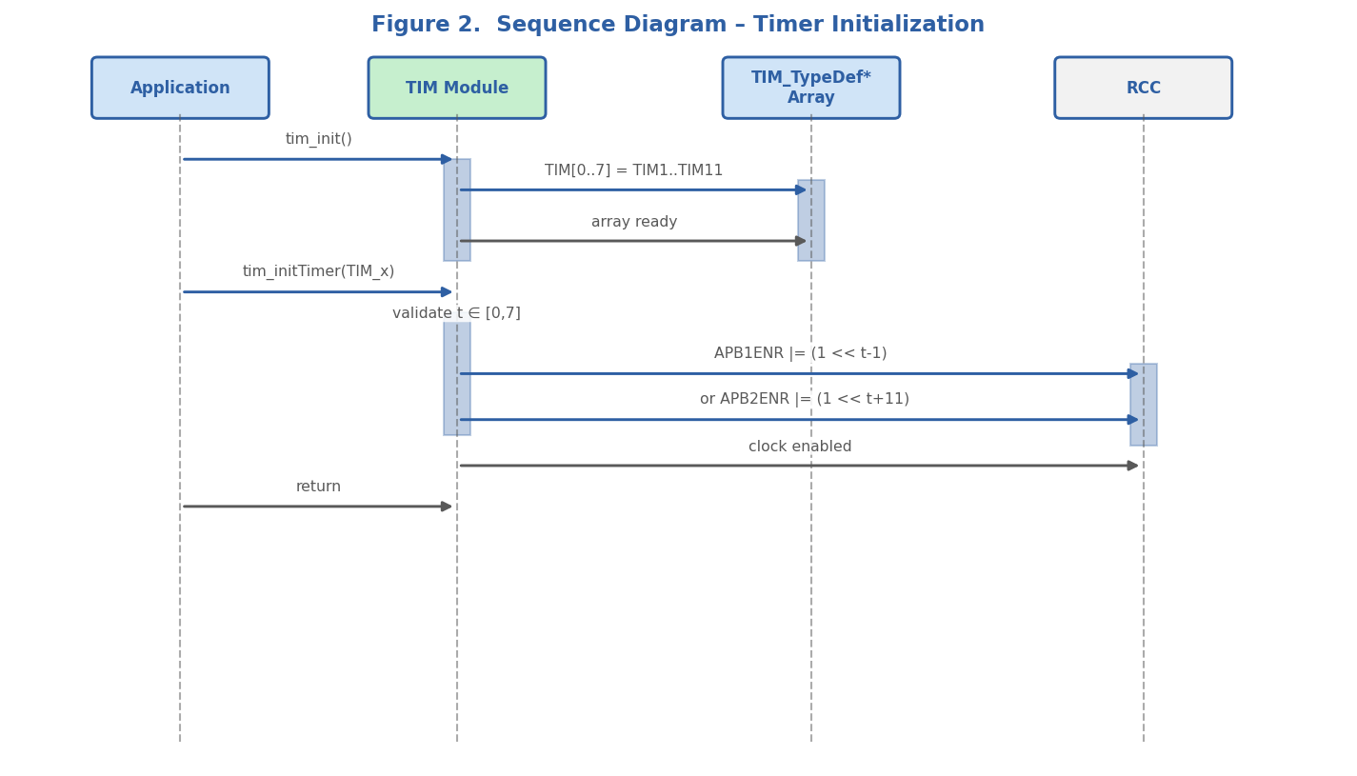
Figure 2. Sequence Diagram – Timer Initialization (tim_init + tim_initTimer)
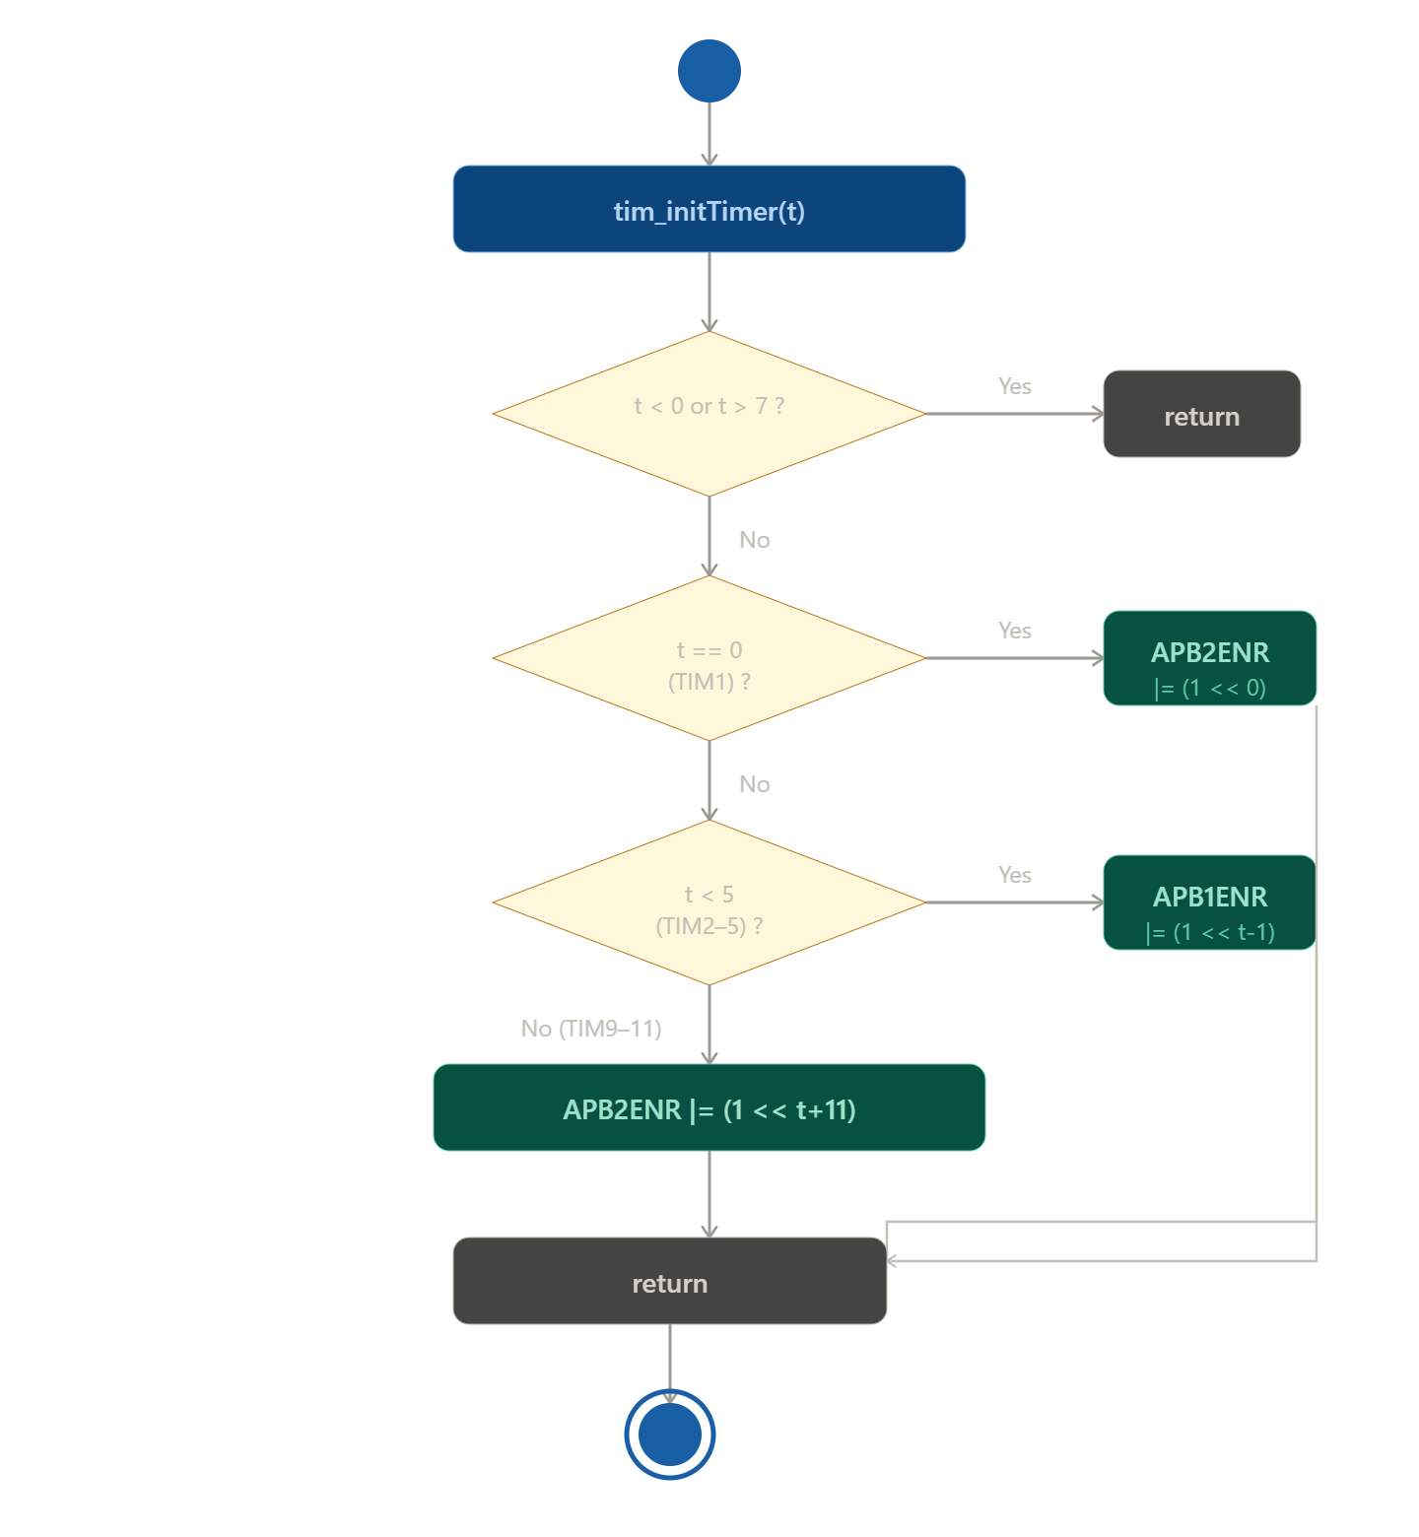
Figure 3. Activity Diagram – tim_initTimer()

3.2.2. Timer Configuration (Conditional Logic)
tim_setTimerMs() and tim_setTimerFreq() both follow a guard-then-configure pattern. The sequence and activity diagrams below use tim_setTimerMs() as the representative example; tim_setTimerFreq() follows the same structure with a frequency-based prescaler computation.

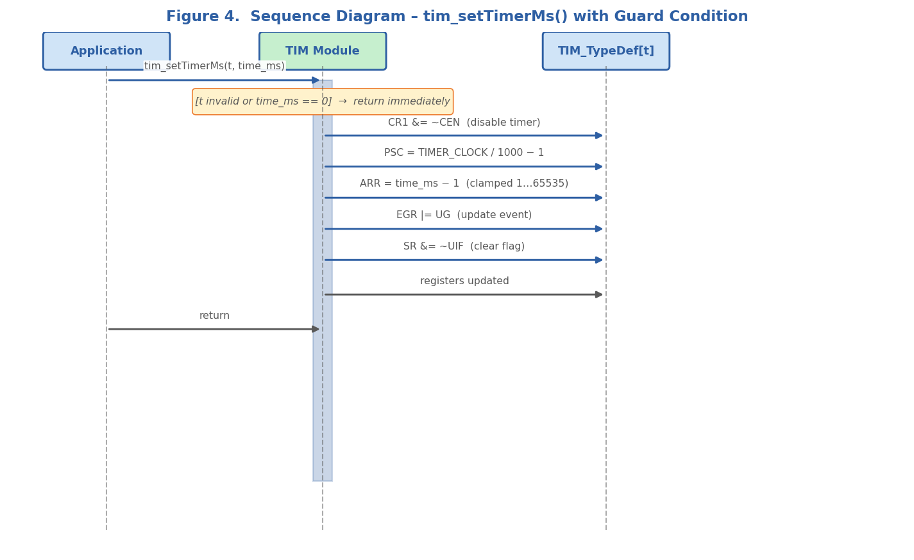
Figure 4. Sequence Diagram – tim_setTimerMs() with Guard Condition
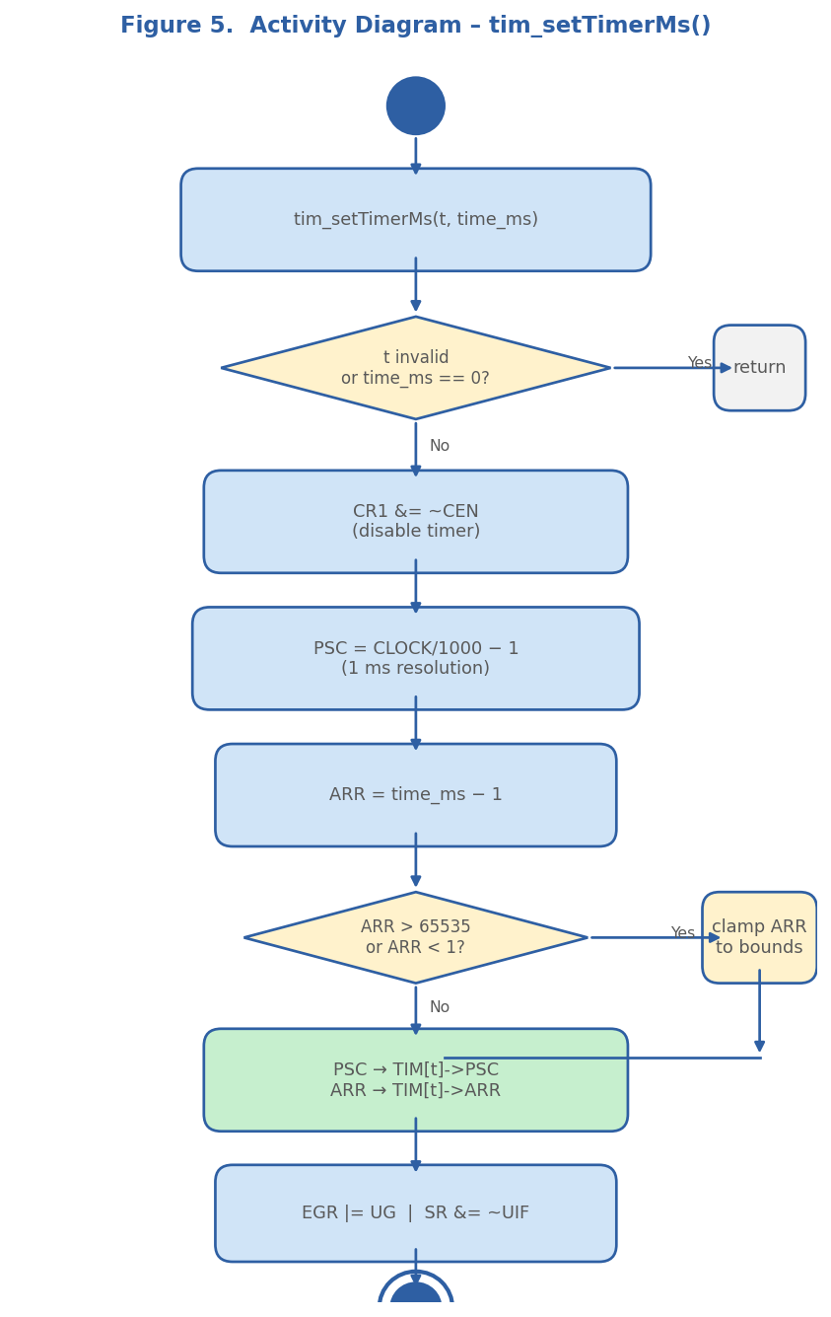
Figure 5. Activity Diagram – tim_setTimerMs()

3.2.3. Blocking Wait (Polling Loop)
tim_waitTimer() implements a blocking spin-wait by polling the Update Interrupt Flag (UIF) inside the status register. The __NOP() call prevents the compiler from optimising away the empty loop body.

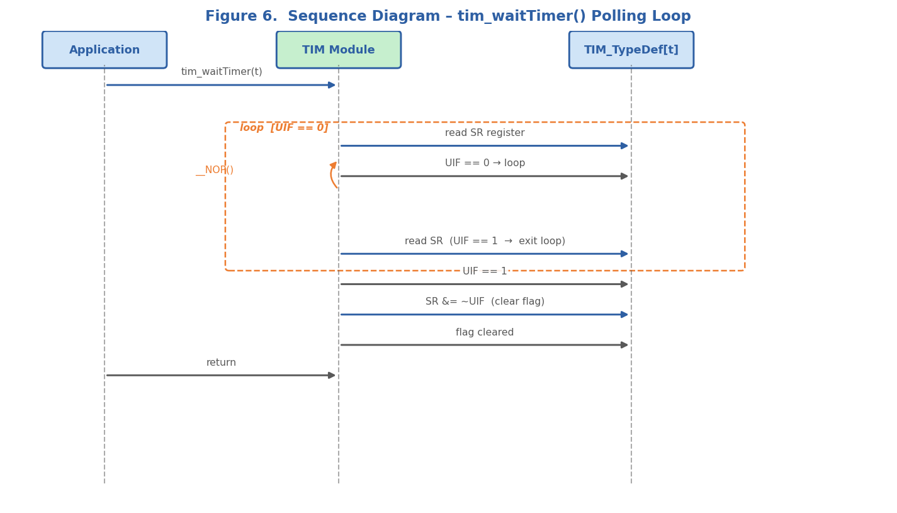
Figure 6. Sequence Diagram – tim_waitTimer() Polling Loop
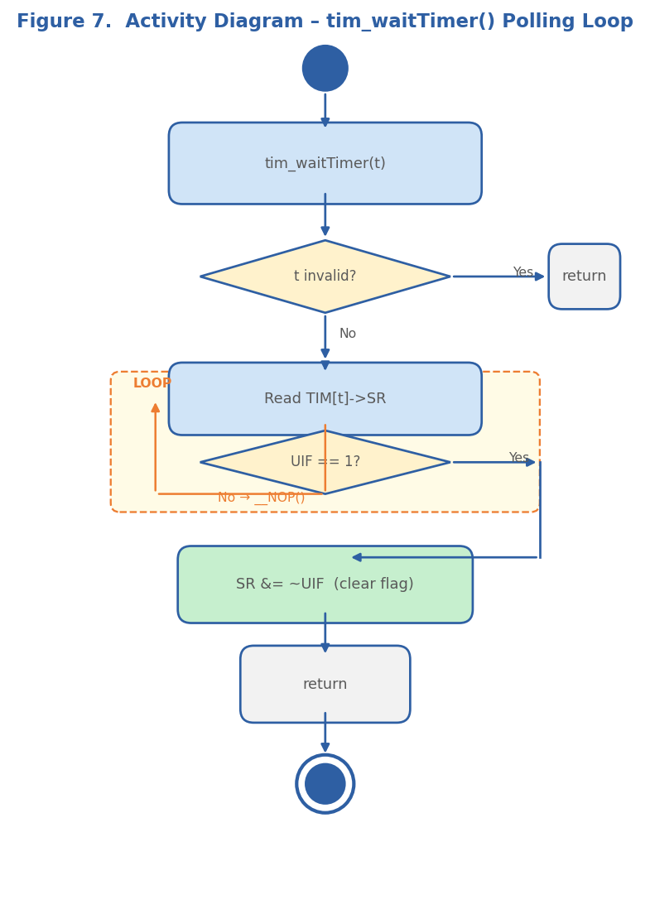
Figure 7. Activity Diagram – tim_waitTimer() Polling Loop

3.2.4. Timer State Machine
Each logical timer managed by this driver transitions through the following states during normal operation:

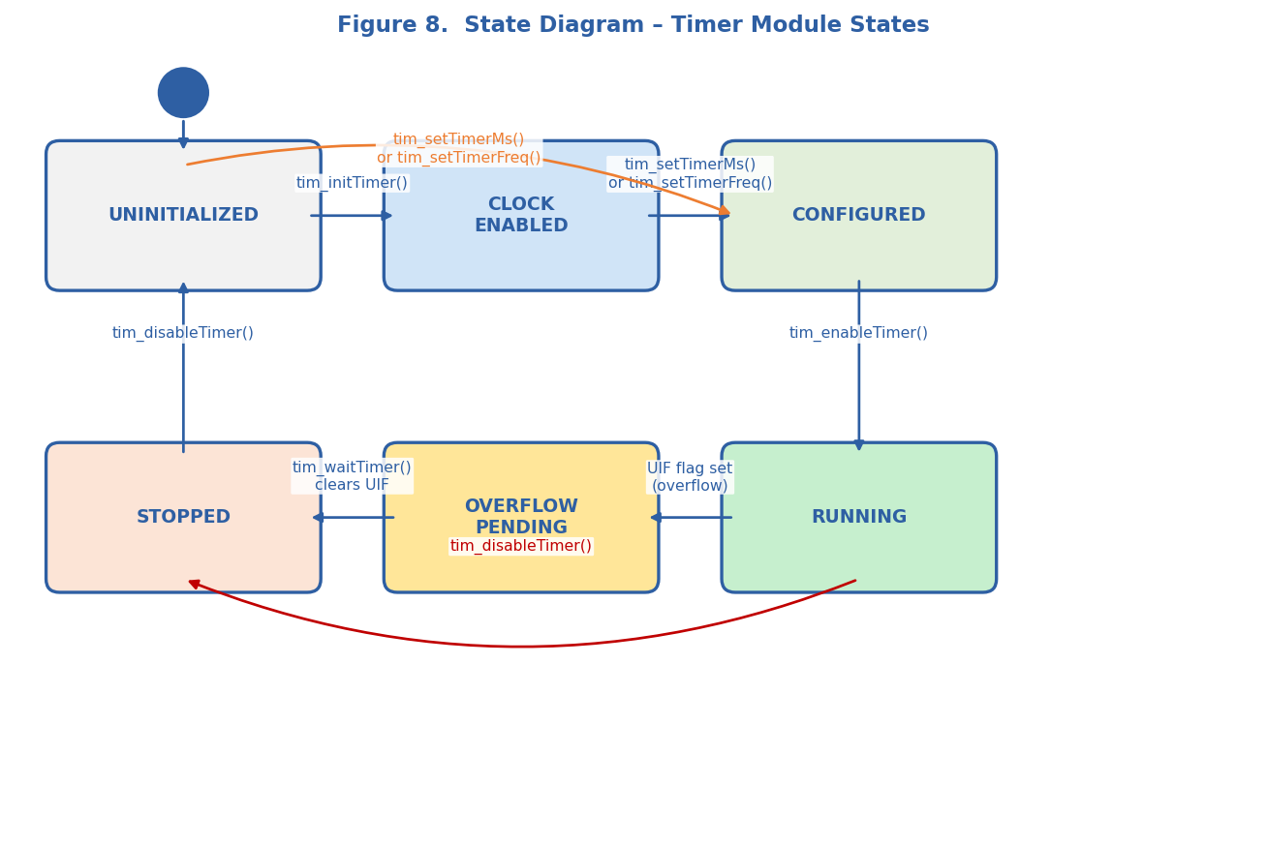
Figure 8. State Diagram – Timer Module States

3.3. TIM Driver — Design Notes
Key design decisions and invariants developers must be aware of:
- Index-to-instance mapping — The global TIM[] array (populated by tim_init()) maps logical indices 0–7 to hardware instances TIM1–TIM11 respectively. All subsequent functions index into this array; hardware is never addressed by name after initialisation.
- Clock enable isolation — tim_initTimer() enables the peripheral clock via the RCC registers. TIM1 is connected to APB2; TIM2–TIM5 to APB1; TIM9–TIM11 to APB2 with different bit positions. The bit-shift formula encodes these rules compactly.
- Prescaler arithmetic — For millisecond delays: PSC = (16 000 000 / 1 000) − 1 = 15 999, giving exactly 1 ms per counter tick. ARR is clamped to the 16-bit hardware range [1, 65 535].
- Frequency arithmetic — For high frequencies (≥ 1 kHz): PSC = 0, ARR = (CLOCK / freq) − 1. For low frequencies: PSC = 15 999, ARR = (CLOCK / (PSC+1) / freq) − 1.
- Update event — After writing PSC and ARR, the EGR UG bit is set to force a register-update event, ensuring the shadow registers are immediately loaded without waiting for the next overflow.
- Re-entrancy — The driver is not re-entrant. Concurrent calls to the same timer index from different tasks or ISRs will produce undefined behaviour.

4. Application Programming Interfaces

4.1. Data Types and Macros
tim_t — Enumeration that represents a logical timer index. Members: TIM_1 (0), TIM_2 (1), TIM_3 (2), TIM_4 (3), TIM_5 (4), TIM_9 (5), TIM_10 (6), TIM_11 (7), TIM_SIZE (8, used as array dimension sentinel).

Member Name | Value | Notes / Definition
TIM_1 | 0 | Maps to TIM1 hardware instance (APB2 bus)
TIM_2 | 1 | Maps to TIM2 hardware instance (APB1 bus)
TIM_3 | 2 | Maps to TIM3 hardware instance (APB1 bus)
TIM_4 | 3 | Maps to TIM4 hardware instance (APB1 bus)
TIM_5 | 4 | Maps to TIM5 hardware instance (APB1 bus)
TIM_9 | 5 | Maps to TIM9 hardware instance (APB2 bus)
TIM_10 | 6 | Maps to TIM10 hardware instance (APB2 bus)
TIM_11 | 7 | Maps to TIM11 hardware instance (APB2 bus)
TIM_SIZE | 8 | Sentinel — used as array dimension; not a valid timer index

TIMER_CLOCK_HZ — Macro that defines the timer input clock frequency. Its value is 16 000 000 (16 MHz), matching the HSI oscillator default on STM32F4xx when no external crystal is used.

4.2. Error Codes
All TIM driver functions return void. Invalid inputs (out-of-range timer index, zero time, unsupported channel, or unsupported mode) cause an immediate silent return without modifying any hardware state. The table below documents the guard conditions used.

Guard Condition | Effect
t < 0 or t > 7 | Function returns immediately; no registers are modified
time_ms == 0 | tim_setTimerMs() returns immediately
freq_hz == 0 or > 16 000 000 | tim_setTimerFreq() returns immediately
channel < 1 or > 4 | Channel functions return immediately
mode > 7 | tim_setTimerCompareMode() returns immediately

4.3. Function Definitions

tim_init
Function Name | tim_init
Syntax | void tim_init(void)
Parameters (in) | None | —
Parameters (inout) | None | —
Parameters (out) | None | —
Return value | void | No return value.
Description | Populates the global TIM[] pointer array by assigning each index to its corresponding hardware timer instance (TIM1 through TIM11). Must be called once before any other TIM function.
Constraints | Must be called before tim_initTimer() or any configuration function. Not thread-safe.
Available via | TIM.h

tim_initTimer
Function Name | tim_initTimer
Syntax | void tim_initTimer(tim_t t)
Parameters (in) | t : tim_t | Logical timer index in range [0, 7].
Parameters (inout) | None | —
Parameters (out) | None | —
Return value | void | No return value.
Description | Enables the RCC peripheral clock for the selected timer. TIM1 and TIM9–TIM11 are on APB2; TIM2–TIM5 are on APB1. The function encodes the correct bit positions via computed shifts.
Constraints | If t is out of range [0, 7] the function returns silently without modifying any register.
Available via | TIM.h

tim_setTimerMs
Function Name | tim_setTimerMs
Syntax | void tim_setTimerMs(tim_t t, uint32_t time_ms)
Parameters (in) | t : tim_t | Logical timer index in range [0, 7].
Parameters (in) | time_ms : uint32_t | Desired delay in milliseconds (must be ≥ 1). Values > 65 536 are clamped to 65 535 ms.
Parameters (inout) | None | —
Parameters (out) | None | —
Return value | void | No return value.
Description | Disables the timer counter, computes PSC = (16 000 000 / 1 000) − 1 for 1 ms resolution, sets ARR = time_ms − 1 (clamped to [1, 65 535]), then forces a register-update event via EGR and clears the UIF flag in SR.
Constraints | Does not re-enable the timer. Caller must call tim_enableTimer() separately. ARR is silently clamped to 65 535 if time_ms is too large.
Available via | TIM.h

tim_setTimerFreq
Function Name | tim_setTimerFreq
Syntax | void tim_setTimerFreq(tim_t t, uint32_t freq_hz)
Parameters (in) | t : tim_t | Logical timer index in range [0, 7].
Parameters (in) | freq_hz : uint32_t | Desired frequency in Hz. Range: [1, 16 000 000].
Parameters (inout) | None | —
Parameters (out) | None | —
Return value | void | No return value.
Description | Disables the timer, selects a PSC/ARR pair based on the frequency range (PSC = 0 for freq ≥ 1 kHz; PSC = 15 999 for freq < 1 kHz), clamps ARR to 16-bit range, writes registers, forces an update event, and clears UIF.
Constraints | Low-frequency precision may be limited by the fixed prescaler of 15 999. Caller must call tim_enableTimer() to start counting.
Available via | TIM.h

tim_enableTimer
Function Name | tim_enableTimer
Syntax | void tim_enableTimer(tim_t t)
Parameters (in) | t : tim_t | Logical timer index in range [0, 7].
Parameters (inout) | None | —
Parameters (out) | None | —
Return value | void | No return value.
Description | Sets the CEN bit (bit 0) in the CR1 register of the selected timer, starting the counter.
Constraints | Timer must be configured (PSC and ARR loaded) before enabling. Enabling an unconfigured timer produces undefined output.
Available via | TIM.h

tim_disableTimer
Function Name | tim_disableTimer
Syntax | void tim_disableTimer(tim_t t)
Parameters (in) | t : tim_t | Logical timer index in range [0, 7].
Parameters (inout) | None | —
Parameters (out) | None | —
Return value | void | No return value.
Description | Clears the CEN bit (bit 0) in CR1, stopping the counter. The current count value in CNT is preserved.
Constraints | The counter is frozen but not reset. Call tim_setTimerMs() or equivalent to reconfigure before re-enabling.
Available via | TIM.h

tim_waitTimer
Function Name | tim_waitTimer
Syntax | void tim_waitTimer(tim_t t)
Parameters (in) | t : tim_t | Logical timer index in range [0, 7].
Parameters (inout) | None | —
Parameters (out) | None | —
Return value | void | No return value.
Description | Blocks the calling context in a tight polling loop until the UIF flag (SR bit 0) is set, indicating a timer overflow. Inserts __NOP() each iteration to prevent compiler optimisation of the empty loop. Clears UIF on exit.
Constraints | Blocking — will never return if tim_enableTimer() was not called first, or if the timer period is set to 0. Not suitable for use inside ISRs.
Available via | TIM.h

tim_setTimerCompareChannelValue
Function Name | tim_setTimerCompareChannelValue
Syntax | void tim_setTimerCompareChannelValue(tim_t t, uint8_t channel, uint16_t compare_value)
Parameters (in) | t : tim_t | Logical timer index in range [0, 7].
Parameters (in) | channel : uint8_t | Channel number (1 to 4).
Parameters (in) | compare_value : uint16_t | Value to load into the corresponding CCRx register.
Parameters (inout) | None | —
Parameters (out) | None | —
Return value | void | No return value.
Description | Writes compare_value into CCR1, CCR2, CCR3, or CCR4 based on the channel argument. The timer counter generates a compare-match event when CNT reaches this value.
Constraints | Channel must be within [1, 4]. The channel must also be configured for compare mode before a match event is meaningful.
Available via | TIM.h

tim_setTimerCompareMode
Function Name | tim_setTimerCompareMode
Syntax | void tim_setTimerCompareMode(tim_t t, uint8_t channel, uint8_t mode)
Parameters (in) | t : tim_t | Logical timer index in range [0, 7].
Parameters (in) | channel : uint8_t | Channel number (1 to 4).
Parameters (in) | mode : uint8_t | Output compare mode code (0–7). Common values: 0 = Frozen, 1 = Active on match, 4 = Force inactive, 6 = PWM mode 1.
Parameters (inout) | None | —
Parameters (out) | None | —
Return value | void | No return value.
Description | Programs the OCxM bits in CCMR1 (channels 1–2) or CCMR2 (channels 3–4) and configures the channel direction bits for output. The shift is computed as (channel−1)*8 for CCMR1 and (channel−3)*8 for CCMR2.
Constraints | Mode values > 7 are rejected. The channel output must be explicitly enabled with tim_enableTimerCompareChannel() after mode configuration.
Available via | TIM.h

tim_enableTimerCompareChannel
Function Name | tim_enableTimerCompareChannel
Syntax | void tim_enableTimerCompareChannel(tim_t t, uint8_t channel)
Parameters (in) | t : tim_t | Logical timer index in range [0, 7].
Parameters (in) | channel : uint8_t | Channel number (1 to 4).
Parameters (inout) | None | —
Parameters (out) | None | —
Return value | void | No return value.
Description | Sets the CCxE bit in the CCER register for the specified channel ((channel−1)*4 bit position), enabling the channel output pin.
Constraints | The compare mode should be configured before enabling the channel output.
Available via | TIM.h

tim_disableTimerCompareChannel
Function Name | tim_disableTimerCompareChannel
Syntax | void tim_disableTimerCompareChannel(tim_t t, uint8_t channel)
Parameters (in) | t : tim_t | Logical timer index in range [0, 7].
Parameters (in) | channel : uint8_t | Channel number (1 to 4).
Parameters (inout) | None | —
Parameters (out) | None | —
Return value | void | No return value.
Description | Clears the CCxE bit in the CCER register, disabling the channel output pin while leaving all other configuration intact.
Constraints | Does not reset the compare value or mode; the channel can be re-enabled without reconfiguration.
Available via | TIM.h

4.4. Internal Function Definitions
There are no private (static) helper functions in this version of the TIM driver. All logic is inlined within the public functions described in Section 4.3. If the driver is refactored in a future version, any internal helpers should be documented here following the same table format.

5. Future Enhancements
- DMA Support — Add tim_enableDMA() / tim_disableDMA() to trigger DMA transfers on timer update or compare events, reducing CPU load in high-frequency data-acquisition scenarios.
- Interrupt-Driven Callback — Add tim_registerCallback(tim_t, void(*cb)(void)) and the corresponding ISR handler to allow non-blocking timer expiry notification without polling in tim_waitTimer().
- PWM Helper API — Introduce tim_setPWM(tim_t, uint8_t channel, float duty_cycle_pct) as a higher-level abstraction over tim_setTimerFreq() and tim_setTimerCompareChannelValue().
- Runtime Error Return — Replace void returns with a tim_status_t enum (TIM_OK, TIM_ERR_INVALID_INDEX, TIM_ERR_INVALID_PARAM) to give callers visibility into configuration failures.
- Input Capture Mode — Extend CCMR configuration to support input-capture mode, enabling frequency measurement and pulse-width detection on external signals.
- HAL Abstraction Layer Integration — Provide a thin adapter that maps this driver to the ST HAL TIM API so that the same application code can target both bare-metal and HAL-based projects.

